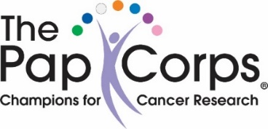

Join Pap for a Ladies Fun Trip
to the
Benzaiten Center for the Creative Arts
1105 S. 2nd Avenue, Lake Worth
The Benzaiten is a 14,500 sq. ft. arts center featuring 2 galleries, a gift shop & 3 public viewing studios with working artists: glass blowing, fusing & flame working.

on Thursday, June 9, 2022
Tour from 10:30 – 12:00
Price: $25 per person
(All checks must be received by June 3rd)
To Pay Via Credit Card press Ctrl & Click Here

Or, please make out your checks payable to “The Pap Corps” and drop off to Roberta Platoff at 7123 Trentino Way. Please mark your checks “Benzaiten” and include your Pap ID number.

Lunch will be on your own – plenty of restaurants on Lake Avenue!
If you have any questions or need directions, please call
Carole Muehlgay at 740-7049

PAPANICOLAOU CORPS FOR CANCER RESEARCH, INC. DBA THE PAP CORPS CHAMPIONS FOR CANCER RESEARCH IS A REGISTERED 501 (C) (3) ORGANIZATION. A COPY OF THE OFFICIAL REGISTRATION AND FINANCIAL INFORMATION MAY BE OBTAINED FROM THE DIVISION OF CONSUMER SERVICES BY CALLING TOLL FREE (800-435-7352), OR WWW.800HELPFLA.COM, WITHIN THE STATE. REGISTRATION DOES NOT IMPLY ENDORSEMENT, APPROVAL, OR RECOMMENDATION BY THE STATE. REGISTRATION #CH2450.

