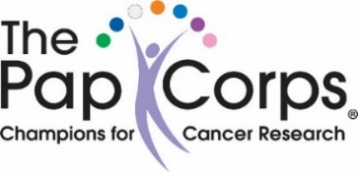
PLEASE NOTE – DUE TO COVID CONCERNS,
WE ARE RESCHEDULING THE COCKTAIL PARTY
NEW DATE IS MARCH 31ST

(You do not have to cruise to join the fun)

Join us for a fun evening
at the Pap Annual Cocktail Party
(Sponsored by Cruise Planners & Celebrity)
“Partners on the Sea – A Day at the Beach”
On
Thursday, March 31, 2022
Friday, January 14, 2022
From 5:00 p.m. – 8:00 p.m.
In the Clubhouse Social Hall

Cost: $20/person
Great food & drinks…..
Sensational Entertainment
& lots of raffle prizes

To make your reservation, you may use a credit card or a check.
By Credit Card: go to: thepapcorps.org click on “Chapters”, then click on
“Closed Chapters”, then click on “Ponte Vecchio”, then click on “Cocktail
Party. Put in all required information. A report will go to Phyllis Schneider.
By Check: Make out check to “The Pap Corps”, and drop it at Phyllis
Schneider’s house - 7136 Lombardy St. Please include your Pap ID on the check and mark it “Cocktail Party”
Any questions, please call either
Susan Dinter at 369-7977, or
Janice Halpern at 516-524-0826

This Photo by Unknown Author is licensed under CC BY-NC

PAPANICOLAOU CORPS FOR CANCER RESEARCH, INC. DBA THE PAP CORPS CHAMPIONS FOR CANCER RESEARCH IS A REGISTERED 501 (C) (3) ORGANIZATION. A COPY OF THE OFFICIAL REGISTRATION AND FINANCIAL INFORMATION MAY BE OBTAINED FROM THE DIVISION OF CONSUMER SERVICES BY CALLING TOLL FREE (800-435-7352), OR WWW.800HELPFLA.COM, WITHIN THE STATE. REGISTRATION DOES NOT IMPLY ENDORSEMENT, APPROVAL, OR RECOMMENDATION BY THE STATE. REGISTRATION #CH2450.

