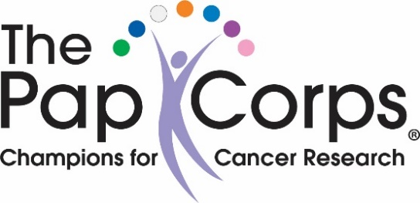

**Order your 2022 Mah Jongg cards now.**



**2022 Mah Jongg Cards**

**The Pap Corps is selling the 2022 Mah Jongg Cards to**

**benefit Cancer Research.**

**Standard print card --- $9.00**

**Large card ----- $10.00**

**Please make checks payable to:**

**“The Pap Corps” & include your membership ID#.**

**Also, please be sure to indicate your mailing address.**

**As of April 1st, the 2022-cards will be sent to your mailing address.**

**Deliver checks to:**

**Phyllis Schneider**

**7136 Lombardy St.**

**Checks must be received no later than DECEMBER 25, 2021!**

**Any questions, please feel free to call Phyllis at 752-3858.**

**Thank you for supporting The Pap Corps & cancer research.**

***Today’s Research will bring Tomorrow’s Cure!***

PAPANICOLAOU CORPS FOR CANCER RESEARCH, INC. DBA THE PAP CORPS CHAMPIONS FOR CANCER RESEARCH IS A REGISTERED 501 (C) (3) ORGANIZATION.  A COPY OF THE OFFICIAL REGISTRATION AND FINANCIAL INFORMATION MAY BE OBTAINED FROM THE DIVISION OF CONSUMER SERVICES BY CALLING TOLL FREE (800-435-7352), OR [WWW.800HELPFLA.COM](http://www.800helpfla.com/), WITHIN THE STATE.  REGISTRATION DOES NOT IMPLY ENDORSEMENT, APPROVAL, OR RECOMMENDATION BY THE STATE.  REGISTRATION #CH2450.