VALENCIA LAKES PAP CORP.

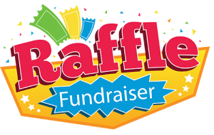

Enter for a chance to “Win $1,000!”
Note: Only 125 raffle tickets will be sold
Your name will be entered into the drawing 1x for each ticket purchased!

PLUS 6 additional winners guaranteed!
Second Winner $500
Third Winner $250
4-Fourth Place Winners $100 Each
$50 PER TICKET
DEADLINE: March 10th or once we sell our “last ticket “
Name of Winner will be drawn at March 15th 2022 Pap Meeting
Increase your chances to win $1,000. Purchase tickets as gifts for friends & family. Share with your card friends. Offer anyone outside of community the opportunity to participate by sending them a copy of the flyer.
Option 1. Print & fill in the info below. Put into envelope. Drop off flyer w/check to Sue’s home or mail to: Sue Champlin - 11407 DeLeon Circle - Boynton Beach, Fl. 33437

Name_________________________________________ Tel. _____________________________
Mailing address _________________________________________________________________
Email address:_________________________________ Number of tickets_________________
Total Amount of check made out to The Pap Corps. $________________ Add ID#_________
___________________________________________________________________________ Option 2. Register online and pay by credit card: https://www.thepapcorps.org/valencia-lakes
Questions: Call Sue Champlin 516-697- 5464 or Phyllis Ives 614-205-4254

