Valencia Shores Cancer Research Chapter 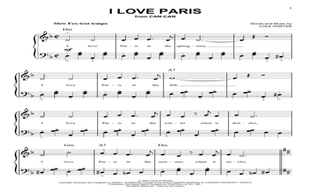

VS PAP CORP PRESENTS
It’s Delightful, It’s De-Lovely
The Life and Songs of Cole Porter
As presented by Harry Getzov – reknowned author, speaker and founder of Eldercation
March 10, 2022 $25pp
coffee and croissants at 9:30am
presentation at 10am
brunch to follow

choice of tuna, egg, or chicken salad (2 scoops), cheese wedge, cracker, lettuce, cucumber, tomato, grapes,
Tables can be set up for up to 6 people
Questions? Contact Kathy Strolla 954 263 8045
"--------------------------------------------------------------------------------------------------------------------------------------------------------------
Please return this form to the Clubhouse with a $25 check for each attendee, payable to The Pap Corps, with Pap ID#. Mark envelope It’s Delightful..
Name ________________________________________ Meal Choice _______________________________________
Name ______________________________________ Meal Choice _______________________________________
Name ________________________________________ Meal Choice ________________________________________ Name________________________________________ Meal Choice ________________________________________
Name ________________________________________ Meal Choice ________________________________________
Name ________________________________________ Meal Choice ________________________________________

