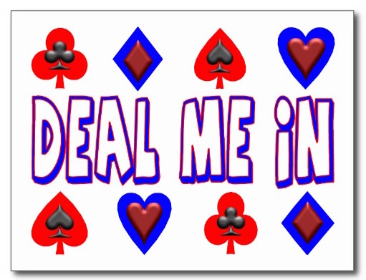
  - Rescheduled WINTER CARD PARTY
In support of THE PAP CORPS
Tuesday March 8th, 2022
10:30 to 4:00
BENVENUTO RESTAURANT
1730 No. Federal Hwy. – Boynton Beach

Separate rooms for CANASTA, BRIDGE, MAH JONGG, POKER, Games. Coffee & snacks during play.
Shop fabulous vendors, then enjoy a plated elegant “3 course meal”.
We will confirm with ALL Prior PAID Registrants of our 2020 Event, there will be no monies due
PRICE: $48. pp new attendees. Payable to “The Pap Corps.” (ID# on check).
Place in Pap mailbox at Club House by Feb.15th. Mark envelope “CARD PARTY”

Menu
Caprese Salad, fresh mozzarella, tomatoes, aged balsamic vinegar
Entrée: A - Chicken Francaise, lemon butter, white wine & parsley
B - Seared Salmon, Chinese five spice with jasmine rice
C - Pasta Primavera
Dessert: 1. Warm chocolate “Lava Cake” with vanilla ice cream
2. Seasonal Fruit
Players Name Entrée Dessert

1.------------------------------------------------------------------------------------------------------ A - B or C 1 or 2
2.------------------------------------------------------------------------------------------------------ A - B or C 1 or 2
3.------------------------------------------------------------------------------------------------------ A - B or C 1 or 2
4.------------------------------------------------------------------------------------------------------ A - B or C 1 or 2
5.------------------------------------------------------------------------------------------------------ A - B or C 1 or 2

Game _________________________ Please include checks & names of all players on one sheet
Questions Call: Joan Tucker 954-562-1817 or Marcy Silverman 215-680-8936

